MEMORANDUM

To: Sisters Park & Recreation District

From: Scott Fregonese

Date: July 5, 2022

Project name: District Needs Assessment

RE: Presentation Summary

Sisters Park & Recreation District sought to better understand the park and recreation
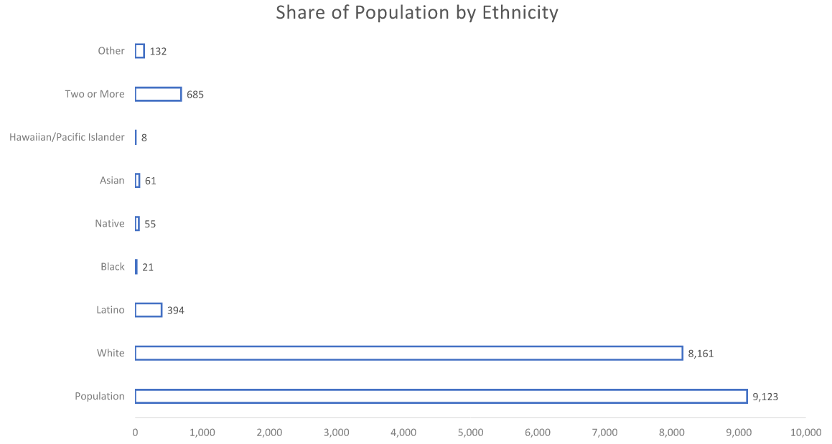
needs of residents. The district conducted a series of focus group meetings with participants representative of the community to learn more about park and recreation needs. Demographic analysis of the Sisters Park & Recreation District accompanied the focus group questions during the presentation. Analysis outlined ethnicity share of population, economic data, educational data, household and age data, and at-risk population data.

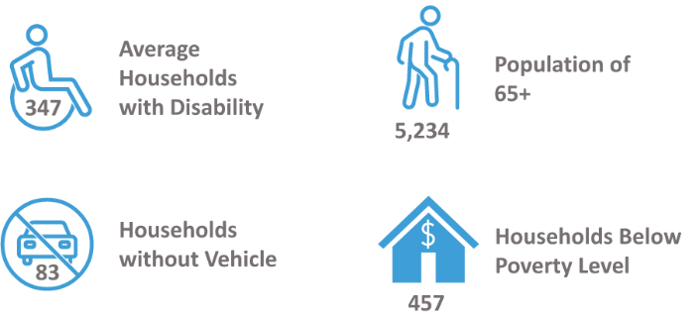
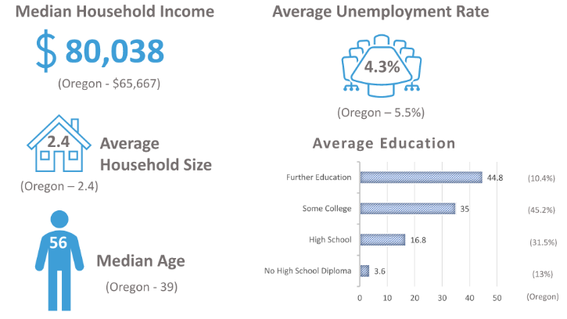
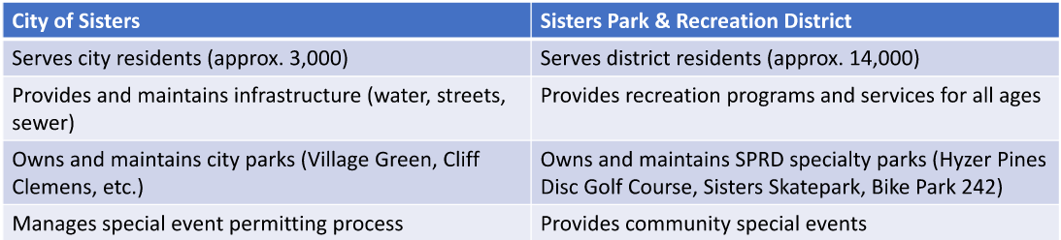
Sisters Park & Recreation District (SPRD) is a special district formed in 1998 to provide after school programs. A separate entity than the City of Sisters, it is funded through a permanent tax rate of .22 per assessed $1,000, or a 5-year local option levy rate of .15 per assessed $1,000 (up for renewal in May 2023. SPRD has an operating budget of approximately $1.5 million and employs 9.5 FTE staff. A comparison of the City of Sisters and SPRD highlights the differing needs:

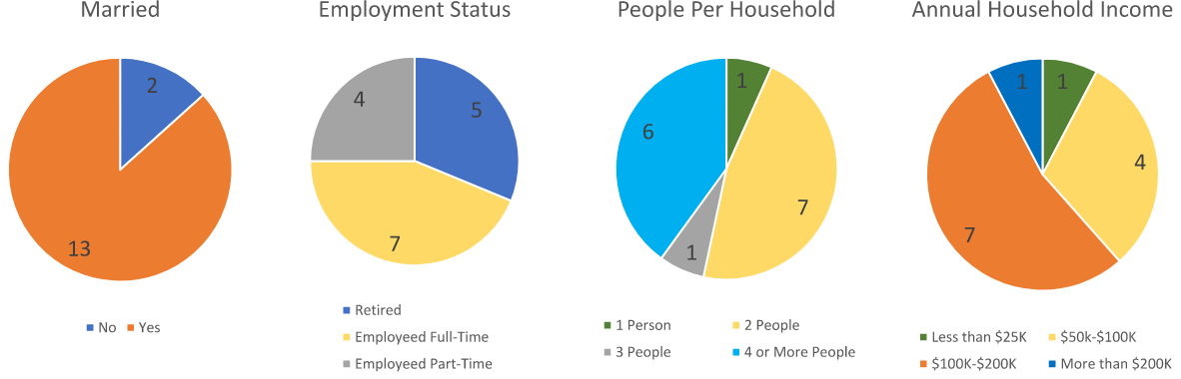
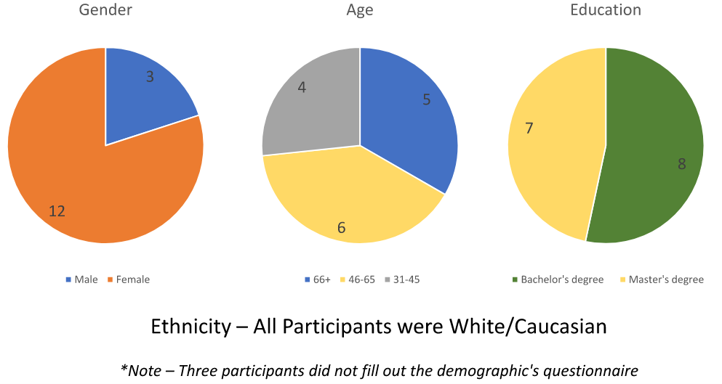
Between June 2nd and 3rd, four focus groups were held at varying times of day. A total of 18 participants were engaged, the participant demographics were:
During each of the four focus groups, 8 questions were asked of the participants:
- Do you live in the City of Sisters or the surrounding area?
- What is your reaction to this list? Were you aware that SPRD provided all these programs? Do any surprise you?
- Are there any recreation programs not currently available that you would like to see in the future?
- Currently, what is the biggest issue or need concerning Sisters Park & Recreation District?
- If you could design the perfect park and recreation district for the Sisters area, what would it be like?
- In general, how satisfied are you with the parks and recreational opportunities currently available from Sisters Park & Recreation District?
- If you seldom use or do not use Sisters Park & Recreation District’s programs, what is the top reason?
- What benefits of the parks and recreation system are most important to you?

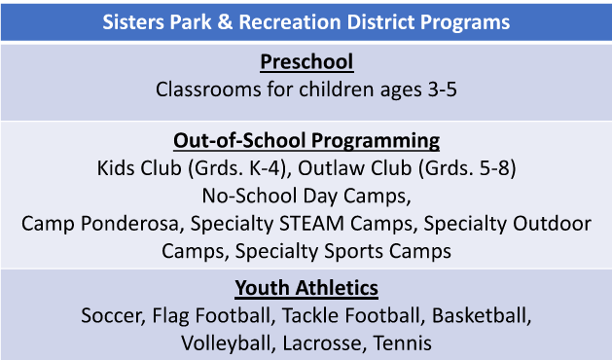
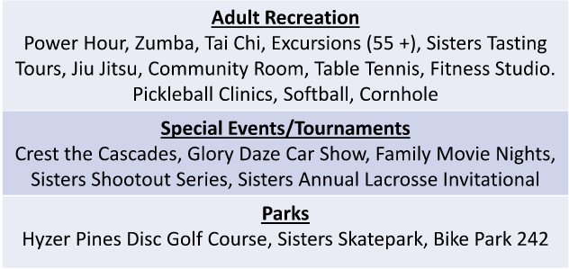
The results of the focus groups were as follows. Question 1 revealed that participants came from the City of Sisters (16) and the surrounding area (22). Question 2 referred to this list:
The general reactions were:
- Surprised that SPRD offers a lot more than expected
- Most did not know about Jiu Jitsu and Tai Chi
- No one had heard of the Sisters Tasting Tour, they were very interested
- They felt that youth recreation seems to be geared toward team sports (bias towards athletics for athletes)
- Participants who had kids were more familiar with the programs
- The preschool and afterschool programs are well liked by the community
- All groups agreed that lacrosse needs to be a state sanctioned sport
- Some High School students didn’t know what SPRD was even though they see the building every day

Question 3 answers revealed the most interest in the following programs:
- Outdoor Programs (Survival/Safety, Art, Science, etc.)
- Pickleball Courts
- Biking (Group Rides, Skills Classes, Mountain Bike Track)
- Swimming (Lessons and a Pool)
- Skiing (Bring back the night skiing program)

General feedback also included a desire for activities for all ages, an ice-skating rink, and a community pool. Outdoor activities were the overarching theme, and there were discussions of the need for more childcare.

Question 4 found the biggest issues or needs of the SPRD to be:
- Staffing (both long-term and seasonal, qualified employees)
- Better branding, messaging, marketing, and general communication
- Funding
- Competition with Bend and Redmond
- Web site and program sign up page need to be updated
  - Signups will be open but then the program will be canceled because not enough people signed up
  - The process of signing up is difficult
  - Registration times are too short
  - Programs get full fast, there may be potential for a better wait list system
  - Website registration is poor and needs work, it crashes, it’s difficult to sign in, can’t often access payment records for tax purposes
  - Process of signup/enrollment is not working; you sign up thinking you are registered then show up and find out you are not on the list

Question 5 answers, regarding what would make a perfect SPRD saw:
- Recreation center (centralized facilities)
- Ice rink (hockey, curling, skating, etc.)
- Indoor and outdoor pool
- Connected trail system
- Senior Center
- More larger parks to create a full parks system
- Pickleball and tennis courts
- Safe place for kids to go with positive activities
- Robust funding
- Good people (Staff & Volunteers)
- Consistency and transparency, good communication to build trust, continuity of programs and philosophy
- More partnerships and overlapping with other organizations (Sisters Athletic Club, Seed to Table, Science Lab, Black Butte facilities, Folk Festival, etc.)

Question 6 comments on satisfaction with SPRD were:
- Overall participants spoke positively about SPRD
- Most said they we satisfied and that things seem to be improving
- Some gave SPRD a “B” but said it should strive for an “A”
- One group gave SPRD a 6 out of 10 score
- One group said that the kids' programs have improved but the adult programs have gone down hill
- One person was dissatisfied because there were no pickleball courts
- One person was not particularly satisfied (mostly due to impacts of COVID-19)
- Satisfied that SPRD is doing the focus groups and listening to the community
- Satisfied with preschool and youth sports
- Satisfied with the great teachers and staff
- Satisfied with the scholarship opportunities
- One person was slightly unsatisfied because there are not as many opportunities as there used to be

Question 7 responses as to why participants don’t currently use SPRD programs were:
- Hard to sign up, registration barriers, needs to be easier
- Timing of the program
- Transportation and accessibility (live too far away)
- Want more programs that aren’t offered
- Programs are geared towards kids, if you don’t have kids, you don’t use the programs as much
- Simply didn’t know that a program was offered

Lastly, question 8 responses highlighted the most important benefits for participants. The top 5 benefits are:
- Community
- Health
- Education
- Connections
- Safe and fun place for kids

In addition to question specific feedback, participants provided general recommendations:
- SPRD needs big ideas now to grab people’s attention if the plan is to go after another levy, really have a plan and communicate it well way ahead of time
- SPRD can run tournaments to increase funding, tournaments can bring in thousands of dollars over a weekend
- COVID has been hard on SPRD, may need to take a loss to reestablish reputation and some programs, a 2–3-year span to develop a successful organization and programing
- Participants wanted to know how the recreation programs ranked in popularity
- Childcare is a huge need in the community
- All groups discussed reusing the grade school to create a community recreation facility (pool, courts, kitchen, classrooms, offices, etc.)
- Participants recommended an SPRD annual calendar
- The idea to develop a system where volunteer hours can be traded for program fees

