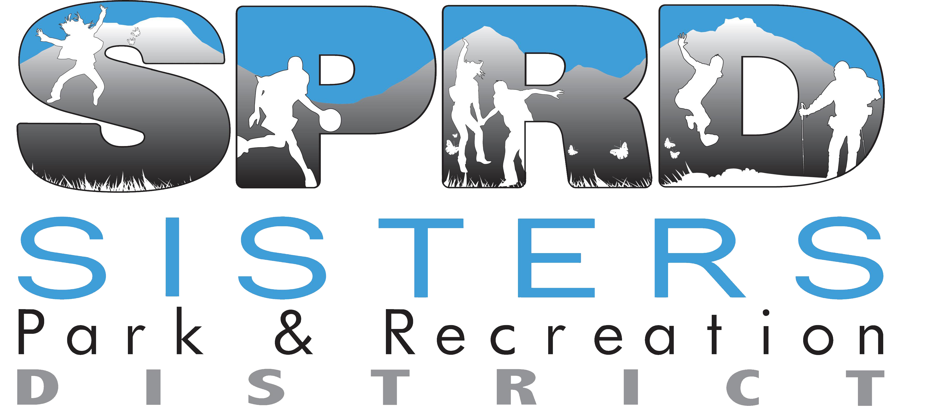

CONTACT INFORMATION:
Sisters Park & Recreation District
Jennifer Holland, Executive Director
(541) 549-2091 x2
jennifer@sistersrecreation.com

NOTICE OF BUDGET COMMITTEE MEETING
A public meeting of the Budget Committee of the Sisters Park & Recreation District, Deschutes County, State of Oregon, to discuss the budget for the fiscal year July 1, 2022 to June 30, 2023 will take place on Tuesday, May 10, 2022 at 4:30 p.m. with the option of continuing the meeting to Wednesday, May 11, 2022 at 4:30 p.m. if needed.

The purpose of this meeting is to receive the budget message and to receive comment from the public on the budget. This is a public meeting where deliberations of the Budget Committee will take place. Any person may attend the meeting at the Coffield Center located at 1750 W. McKinney Butte, Sisters, Oregon and discuss the proposed programs with the Budget Committee.

A copy of the budget document may be viewed or obtained on or after April 29, 2022 by emailing SPRD@sistersrecreation.com or calling (541) 549-2091. Concurrently posted on the Sisters Park & Recreation District website at www.sistersrecreation.com.

Published:
The Nugget, April 27, 2022
May 4, 2022

